//1.a) Write a program (WAP) in C to display your 10th marksheet.

#include<stdio.h>

#include<math.h>

#include<conio.h>

void main()

{

int eng1,maths1,phyed1,comp1,hindi1,science1,total1;

char name[30],roll1[20],board1[30],name2[30],school[40];

clrscr();

printf("\n\t\t Enter 10th marksheet Details\t\t");

printf("\nEnter Your name :");

scanf("%s",&name);

printf("Enter Your Roll NO. :");

scanf("%s",&roll1);

printf("Enter Your father name :");

scanf("%s",&name2);

printf("Enter Your school name :");

scanf("%s",&school);

printf("Enter Board Name :");

scanf("%s",&board1);

printf("\nEnter English marks :");

scanf("%d",&eng1);

printf("Enter Hindi marks :");

scanf("%d",&hindi1);

printf("Enter maths marks :");

scanf("%d",&maths1);

printf("Enter science marks :");

scanf("%d",&science1);

printf("Enter computer marks :");

scanf("%d",&comp1);

printf("Enter physical marks :");

scanf("%d",&phyed1);

total1 = eng1 + maths1 + hindi1 + comp1 +science1 +phyed1;

printf("\n\n\t\t\t10th marksheet ");

printf("\nName :%s",name);

printf("\nRoll no. :%s",roll1);

printf("\nfather Name :%s",name2);

printf("\nschool name :%s",school);

printf("\nBoard :%s",board1);

printf("\n\nSubject\t\t\tmax.marks\t\t marks ");

printf("\n\nEnglish\t\t\t100\t\t\t%d",eng1);

printf("\nHindi\t\t\t100\t\t\t%d",hindi1);

printf("\nMaths\t\t\t100\t\t\t%d",maths1);

printf("\nScience\t\t\t100\t\t\t%d",science1);

printf("\nComputer\t\t100\t\t\t%d",comp1);

printf("\nPhysical\t\t100\t\t\t%d",phyed1);

printf("\n\nTotal\t\t\t600\t\t\t%d",total1);

if(total1<198)

{

printf("\nResult\t\t\t\tFail");

}

else

printf("\nResult\t\t\t\t\tPass");

getch();

}

***OUTPUT***

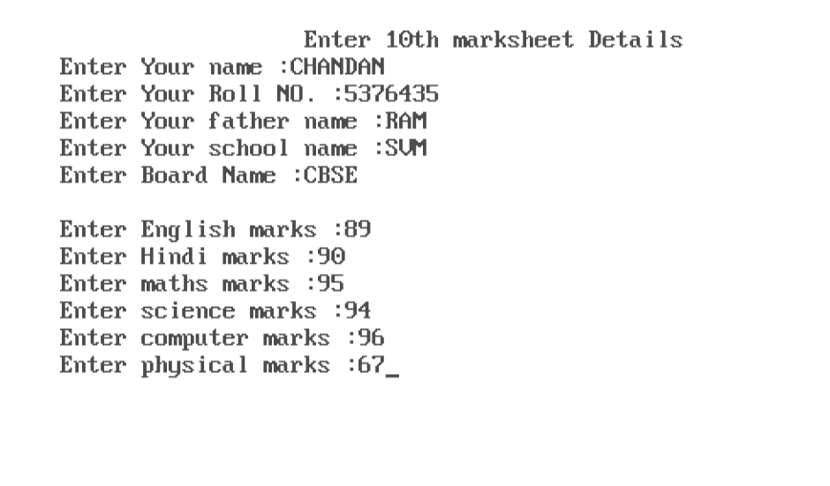

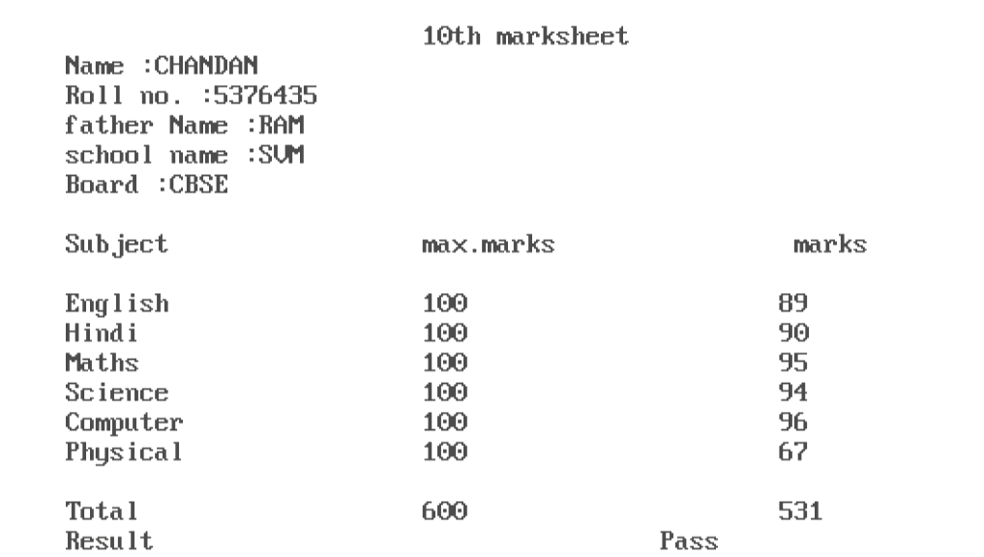

//1.b) WAP to print the following pattern using the printf():

#include<stdio.h>

#include<conio.h>

#include<math.h>

void main()

{

clrscr();

printf("\n *\n * *\n* * *\n * *\n *\n");

getch();

}

**OUTPUT**

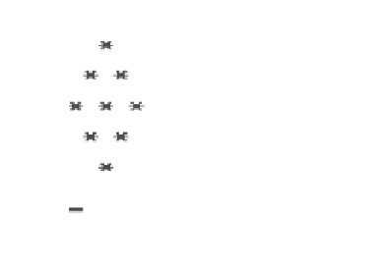

/*2.a) WAP to perform addition, subtraction, multiplication,

division, and modulus of 2 numbers, when the inputs are:*/

#include<stdio.h>

#include<math.h>

#include<conio.h>

void main()

{

int x1=1,x2=1,y1=2,y3=2;

float x3=3.0,x4=4.0,y2=2.0,y4=7.0;

int add1,sub1,mul1,div1,mod1;

float add2,sub2,mul2,div2,mod2;

float add3,sub3,mul3,div3,mod3;

float add4,sub4,mul4,div4,mod4;

clrscr();

printf("\n\nThe Arithmatic operation for input x=1 , y=2");

printf("\nThe sum is :%d",add1=x1+y1);

printf("\nThe diff. is :%d",sub1=x1-y1);

printf("\nThe product is :%d",mul1=x1*y1);

printf("\nThe quotient is :%d",div1=x1/y1);

printf("\nThe remainder is :%d",mod1=x1%y1);

printf("\n\nThe Arithmatic operation for input x=1 , y=2.0");

printf("\nThe sum is :%f",add2=x2+y2);

printf("\nThe diff. is :%f",sub2=x2-y2);

printf("\nThe product is :%f",mul2=x2*y2);

printf("\nThe quotient is :%f",div2=x2/y2);

printf("\nThe remainder is :%f",mod2=x2%2);

printf("\n\nThe Arithmatic operation for input x=3.0 , y=2");

printf("\nThe sum is :%f",add3=x3+y3);

printf("\nThe diff. is :%f",sub3=x3-y3);

printf("\nThe product is :%f",mul3=x3*y3);

printf("\nThe quotient is :%f",div3=x3/y3);

printf("\nThe remainder is :%f",mod3=3%y3);

printf("\n\nThe Arithmatic operation for input x=4.0 , y=7.0");

printf("\nThe sum is :%f",add4=x4+y4);

printf("\nThe diff. is :%f",sub4=x4-y4);

printf("\nThe product is :%f",mul4=x4*y4);

printf("\nThe quotient is :%f",div4=x4/y4);

printf("\nThe remainder is :%f",mod4=4%7);

getch();

}

**OUTPUT**

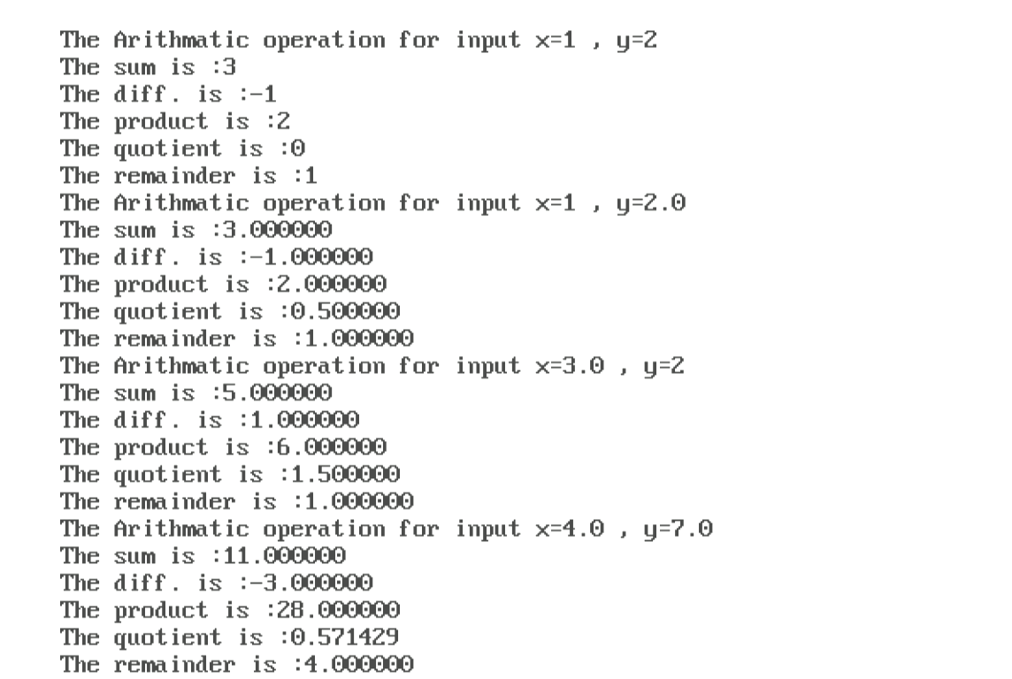

//2.b)WAP to convert Celsius to Fahrenheit using the formula: °F = °C × (9/5) + 32.

#include<stdio.h>

#include<math.h>

#include<conio.h>

void main()

{

float celcius,ferhenheit;

clrscr();

printf("Enter Temperature in celcius :");

scanf("%f",&celcius);

ferhenheit = celcius * 9/5 +32;

printf("Temperature in Ferhenheit is %f",ferhenheit);

getch();

}

**OUTPUT**

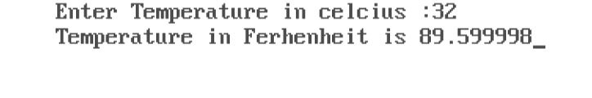

// 3.ai) WAP to swap two numbers using 2 variables.

#include<stdio.h>

#include<math.h>

#include<conio.h>

void main()

{

int a,b;

clrscr();

printf("Enter the value of a and b : ");

scanf("%d %d", &a ,&b);

printf("\nThe value of a and b before swapping is : %d %d",a,b);

a=a+b;

b=a-b;

a=a-b;

printf("\nThe value of a and b after swapping is : %d %d",a , b);

getch();

}

**OUTPUT**

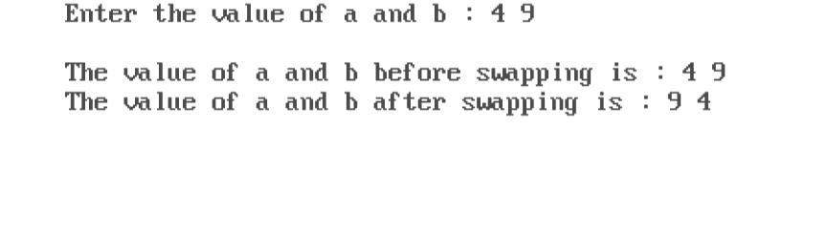

// 3.aii) WAP to swap two numbers using 3 variables.

#include<stdio.h>

#include<math.h>

#include<conio.h>

void main()

{

int a,b,c;

clrscr();

printf("Enter the value of a and b : ");

scanf("%d %d", &a ,&b);

printf("\nThe value of a and b before swapping is : %d %d",a,b);

c=a;

a=b;

b=c;

printf("\nThe value of a and b after swapping is : %d %d",a , b);

getch();

}

**OUTPUT**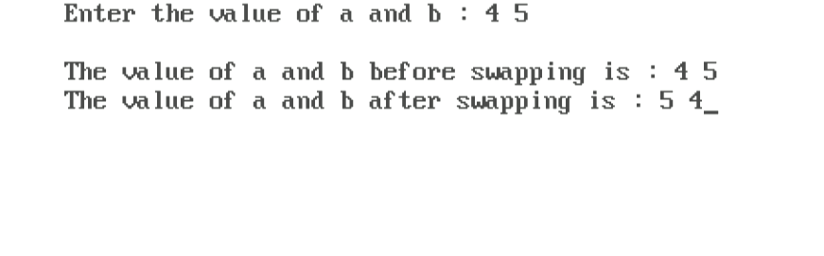

//3 b) WAP to find the Simple Interest when the user inputs Principle, Rate, and Time.

#include<stdio.h>

#include<math.h>

#include<conio.h>

void main()

{

float p,r,t,si; //p:principle r:rate t:time si:simple interest

clrscr();

printf("Enter Principle :");

scanf("%f",&p);

printf("Enter Rate :");

scanf("%f",&r);

printf("Enter Time in years :");

scanf("%f",&t);

si=p*r*t/100;

printf("\nThe Simple Interest is :%f",si);

getch();

}

**OUTPUT**

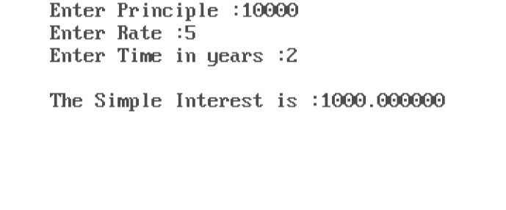

**4.a) WAP for finding the average and grades of students obtained in the three subjects.**

#include<stdio.h>

#include<conio.h>

#include<math.h>

void main()

{

int physics,chemistry,computer;

int avrg;

clrscr();

printf("Enter physics marks :");

scanf("%d",&physics);

printf("Enter chemistry marks :");

scanf("%d",&chemistry);

printf("Enter computer marks :");

scanf("%d",&computer);

avrg = (physics + chemistry + computer)/3;

printf("\nAverage is :%d ",avrg);

if(avrg>=60){

printf("\nThe Grade is 'A'");

}

else

if (avrg>=50 && avrg<60){

printf("\nThe Grade is 'B'");

}

else

if (avrg>=40 && avrg<50){

printf("\nThe Grade is 'C'");

}

else

if (avrg>=30 && avrg<40){

printf("\nThe Grade is 'D'");

}

else

if (avrg<30){

printf("\nThe Grade is 'E'");

}

getch();

}

**Name-Chandan Kumar Shah**

***OUTPUT***

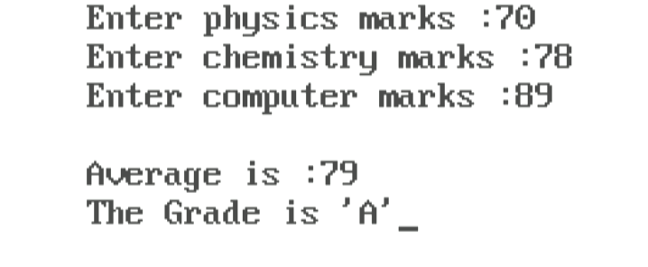**4.b) WAP to check whether a given number is even or odd using the switch case.**

#include<stdio.h>

#include<conio.h>

#include<math.h>

void main()

{

int a,b;

clrscr();

printf("Enter a No. to check even or odd :");

scanf("%d",&a);

b=a%2;

switch(b){

case 0:

printf("\nNumber is Even");

break;

case 1:

printf("\nNumber is Odd");

break;

}

getch();

}

***OUTPUT***

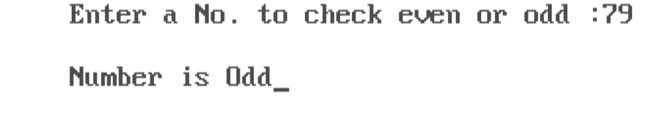

**5.a) WAP to find the sum of digits of a four-digit number and reverse, entered by the user.**

#include <stdio.h>

#include <conio.h>

#include <math.h>

void main()

{

    int n, m, a, b, sum, rev;

    sum = 0;

    rev = 0;

    printf("Enter no.to find sum of digit and reverse : ");

    scanf("%d", &n);

    a = n;

    while (n > 0)

    {

        m = n % 10;

        sum = sum + m;

        rev = rev * 10 + m;

        n = n / 10;

    }

    printf("The sum of digit is : %d", sum);

    printf("\nThe reverse of digit is : %d", rev);

    getch();

}

***OUTPUT***

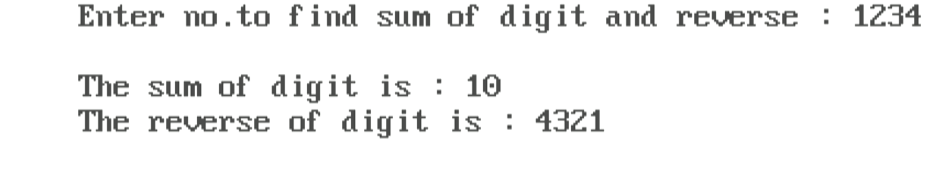

**5.b)WAP using loops to calculate and print the first m Fibonacci numbers.**

#include <stdio.h>

#include <conio.h>

#include <math.h>

void main()

{

    int n, i, a, b, c;

    a = 0;

    b = 1;

    printf("Enter no. to print n no. of fibonacci series :");

    scanf("%d", &n);

    printf("\nthe fibonacci series is :");

    for (i = 0; i <n; i++)

    {

        printf(" %d", a);

        c = a + b;

        a = b;

        b = c;

    }

    getch();

}

***OUTPUT***

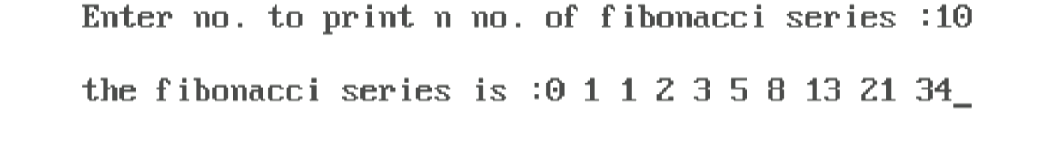

**5.c) WAP to print the Pascal’s triangle:**

#include <stdio.h>

#include <conio.h>

void main()

{

    int n, i, j, k, c;

    clrscr();

    printf("Enter no. of rows :");

    scanf("%d", &n);

    for (i = 1; i <= n; i++)

    {

        for (j = 1; j <= n - i; j++)

            printf(" ");

        c = 1;

        for (k = 1; k <= i; k++)

        {

            printf("%3d", c);

            c = c * (i - k) / k;

        }

        printf("\n");

    }

    getch();

}

***OUTPUT***

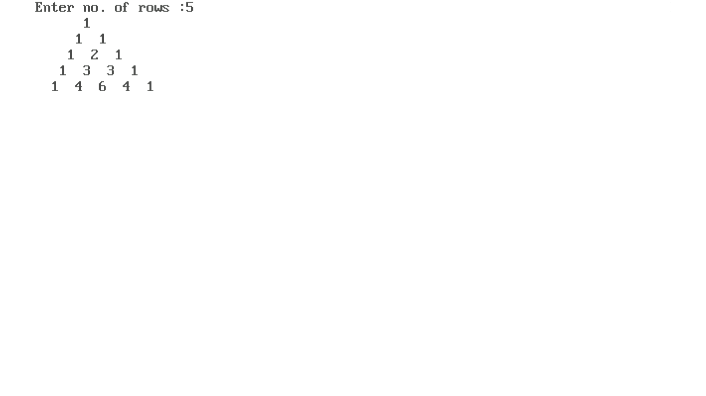

**6.a) Design a function leap( ) that receives a year as a parameter and checks whether the year is a leap year or not and returns an appropriate message.**

#include<stdio.h>

#include<conio.h>

int leap(int year)

{

if (year % 4 == 0 && year % 100 != 0 || year % 400 == 0)

return 1;

else

{

return 0;

}

}

void main()

{

int year, a;

clrscr();

printf("Enter the year :");

scanf("%d", &year);

a = leap(year);

if (a == 1)

printf("\nEntered Year %d is a Leap Year", year);

else

printf("Entered Year %d is not a Leap year", year);

getch();

}

***OUTPUT***

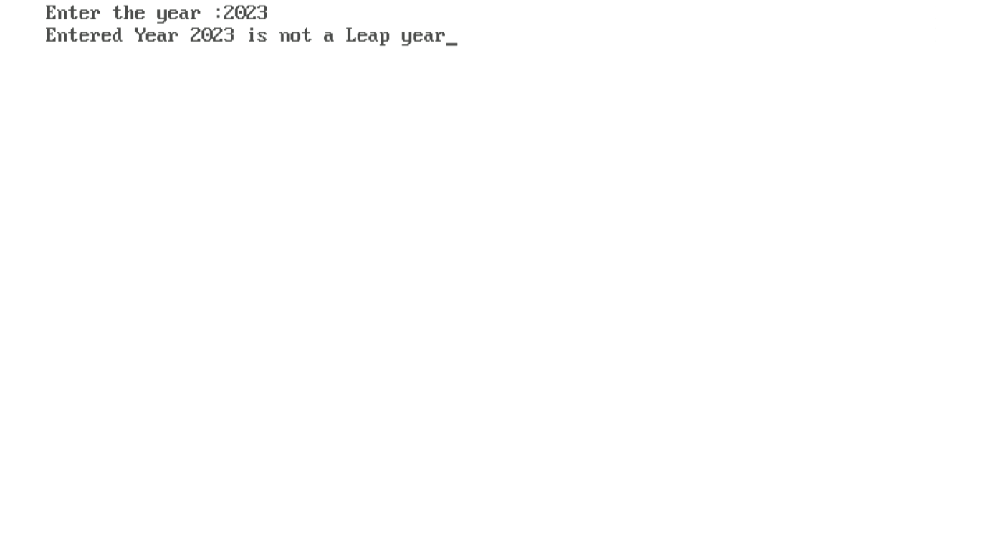

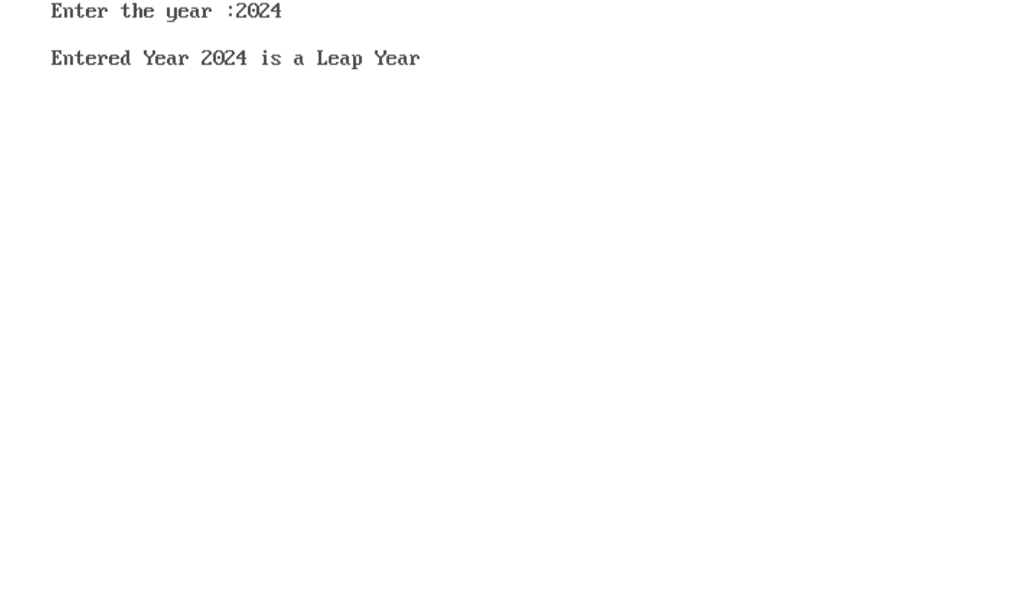

**6.b) Develop a top_down modular program to implement a calculator. The program should request the user to input two numbers and display one of the following as per the user’s choice:**

* + - 1. **Sum of the numbers**
      2. **Difference of the numbers**
      3. **Product of the numbers**
      4. **Division of the numbers**

#include <stdio.h>

#include <conio.h>

void input(double *num1, double *num2)

{

printf("Enter first numbers: ");

scanf("%lf", num1);

printf("Enter second numbers: ");

scanf("%lf", num2);

}

double Sum(double num1, double num2)

{

return num1 + num2;

}

double Difference(double num1, double num2)

{

return num1 - num2;

}

double Product(double num1, double num2)

{

return num1 * num2;

}

double Division(double num1, double num2)

{

if (num2 == 0)

{

printf("Error: Division by zero is not allowed.\n");

return 0.0;

}

return num1 / num2;

}

void Output(double result)

{

printf("Result: %.2lf\n", result);

}

void main()

{

double num1, num2;

int choice;

char ch;

double result;

clrscr();

input(&num1, &num2);

printf("Choose an operation:\n");

printf("1. Sum\n");

printf("2. Difference\n");

printf("3. Product\n");

printf("4. Division\n");

printf("Enter your choice (1/2/3/4): ");

scanf("%d", &choice);

switch (choice)

{

case 1:

result = Sum(num1, num2);

Output(result);

break;

case 2:

result = Difference(num1, num2);

Output(result);

break;

case 3:

result = Product(num1, num2);

Output(result);

break;

case 4:

result = Division(num1, num2);

Output(result);

break;

default:

printf("Invalid choice, please enter valid choice :\n");

break;

}

getch();

}

***OUTPUT***

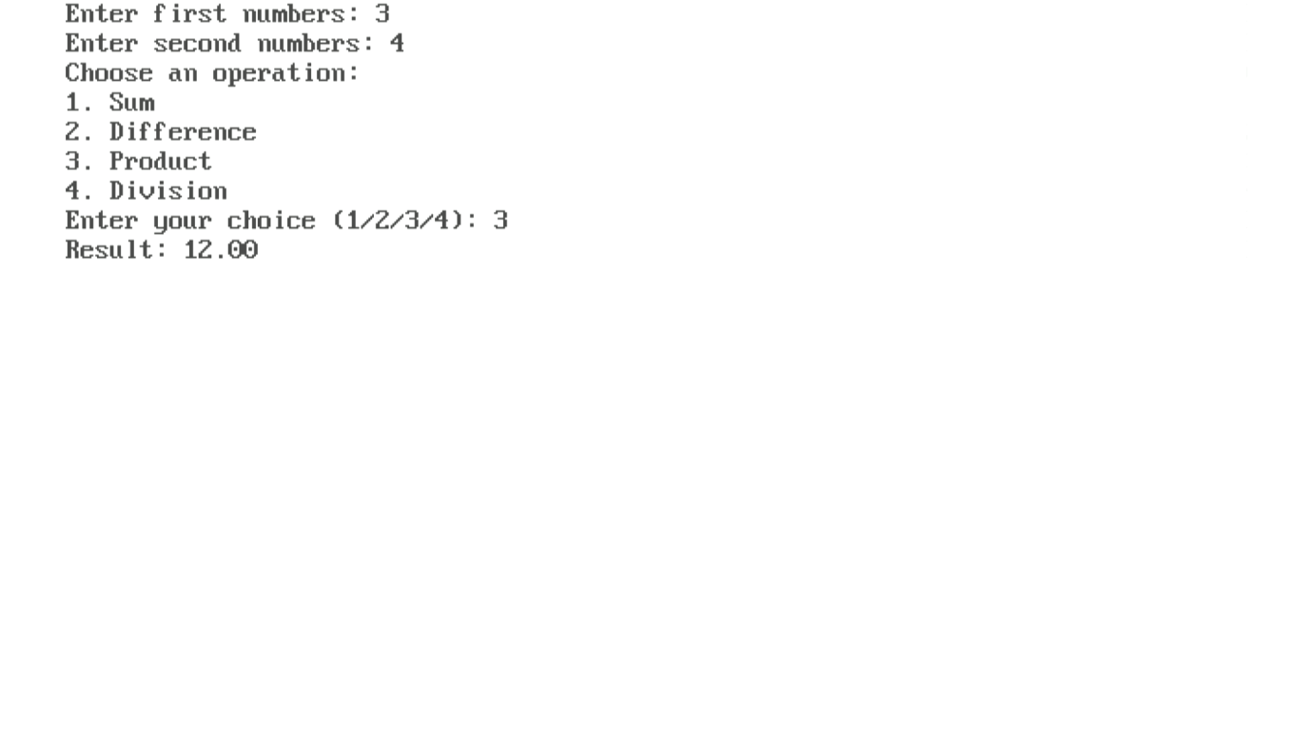

**6.c) WAP to get the factorial of a number using recursion .**

#include <stdio.h>

#include <conio.h>

unsigned long long factorial(int n)

{

    if (n == 1)

    {

        return 1;

    }

    else

    {

        return n * factorial(n - 1);

    }

}

void main()

{

    int num;

    clrscr();

    printf("Enter a non-negative integer: ");

    scanf("%d", &num);

    if (num < 0)

    {

        printf("Factorial is not defined for negative numbers.\n");

    }

    else

    {

        unsigned long long result = factorial(num);

        printf("The factorial of %d is  %llu\n", num, result);

    }

    getch();

}

***OUTPUT***

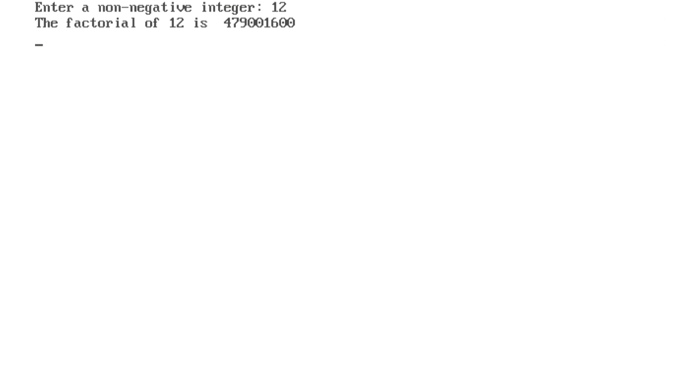

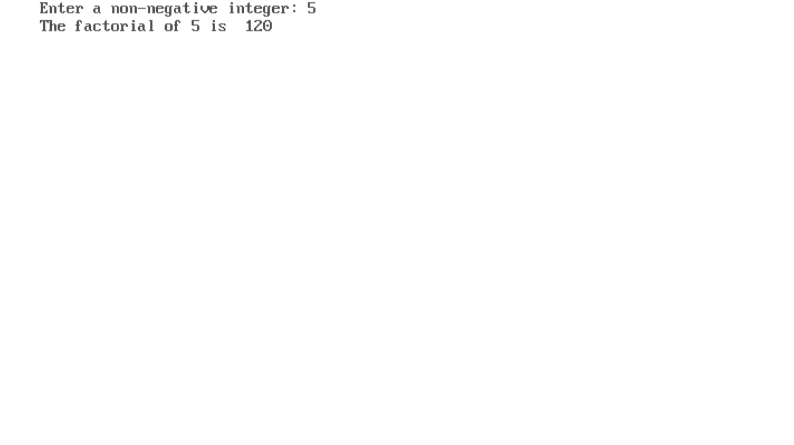

**7.a) WAP to find the maximum among the numbers entered in an array of size 10.**

#include <stdio.h>

#include <conio.h>

void main()

{

    int arr[10], i;

    clrscr();

    printf("Enter 10 elements of array: ");

    for (i = 0; i < 10; ++i)

    {

        scanf("%d", &arr[i]);

    }

    for (i = 1; i < 10; ++i)

    {

        if (arr[0] < arr[i])

        {

            arr[0] = arr[i];

        }

    }

    printf("max number in array is = %d", arr[0]);

    getch();

}

***OUTPUT***

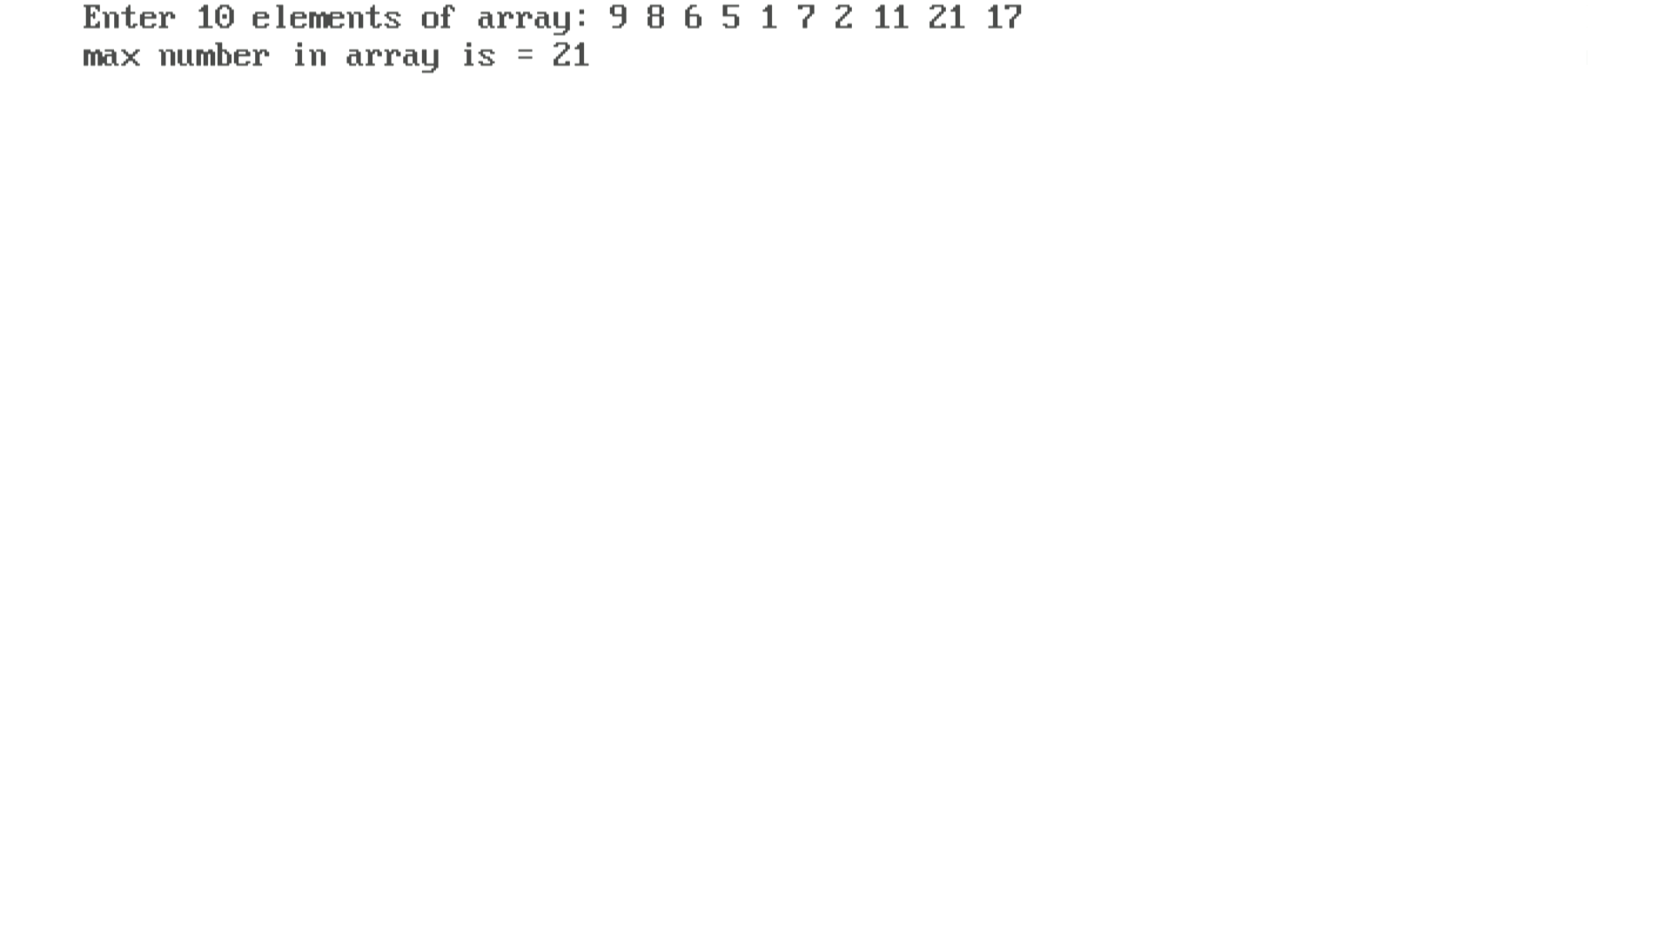

**7. b) WAP for the addition and multiplication of two matrices of order 3x3, and also find the transpose of this matrix.**

#include <stdio.h>

#include <conio.h>

void addMatrices(int A[3][3], int B[3][3], int result[3][3])

{

    int i, j;

    for (i = 0; i < 3; ++i)

    {

        for (j = 0; j < 3; ++j)

        {

            result[i][j] = A[i][j] + B[i][j];

        }

    }

}

void multiplyMatrices(int A[3][3], int B[3][3], int result[3][3])

{

    int i, j, k;

    for (i = 0; i < 3; ++i)

    {

        for (j = 0; j < 3; ++j)

        {

            result[i][j] = 0;

            for (k = 0; k < 3; ++k)

            {

                result[i][j] += A[i][k] * B[k][j];

            }

        }

    }

}

void transposeMatrix(int A[3][3], int result[3][3])

{

    int i, j;

    for (i = 0; i < 3; ++i)

    {

        for (j = 0; j < 3; ++j)

        {

            result[i][j] = A[j][i];

        }

    }

}

void inputMatrix(int mat[3][3])

{

    int i, j;

    for (i = 0; i < 3; ++i)

    {

        for (j = 0; j < 3; ++j)

        {

            printf("Enter element at position [%d][%d]: ", i + 1, j + 1);

            scanf("%d", &mat[i][j]);

        }

    }

}

void printMatrix(int mat[3][3])

{

    int i, j;

    for (i = 0; i < 3; ++i)

    {

        for (j = 0; j < 3; ++j)

        {

            printf("%d ", mat[i][j]);

        }

        printf("\n");

    }

}

void main()

{

    int A[3][3], B[3][3], result[3][3];

    clrscr();

    printf("Enter First matrix \n");

    inputMatrix(A);

    printf("\nEnter Second matrix \n");

    inputMatrix(B);

    addMatrices(A, B, result);

    printf("Matrix Addition :\n");

    printMatrix(result);

    printf("\n");

    multiplyMatrices(A, B, result);

    printf("Matrix Multiplication :\n");

    printMatrix(result);

    printf("\n");

    transposeMatrix(A, result);

    printf("Matrix Transpose of first matrix:\n");

    printMatrix(result);

    transposeMatrix(B, result);

    printf("Matrix Transpose of Second matrix:\n");

    printMatrix(result);

    getch();

}

***OUTPUT***

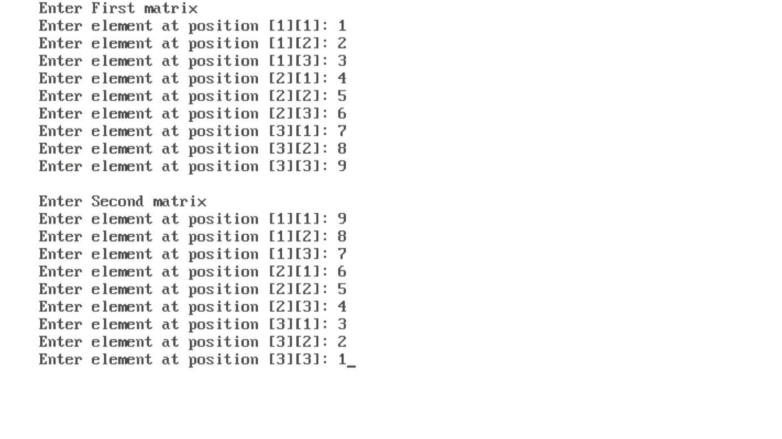

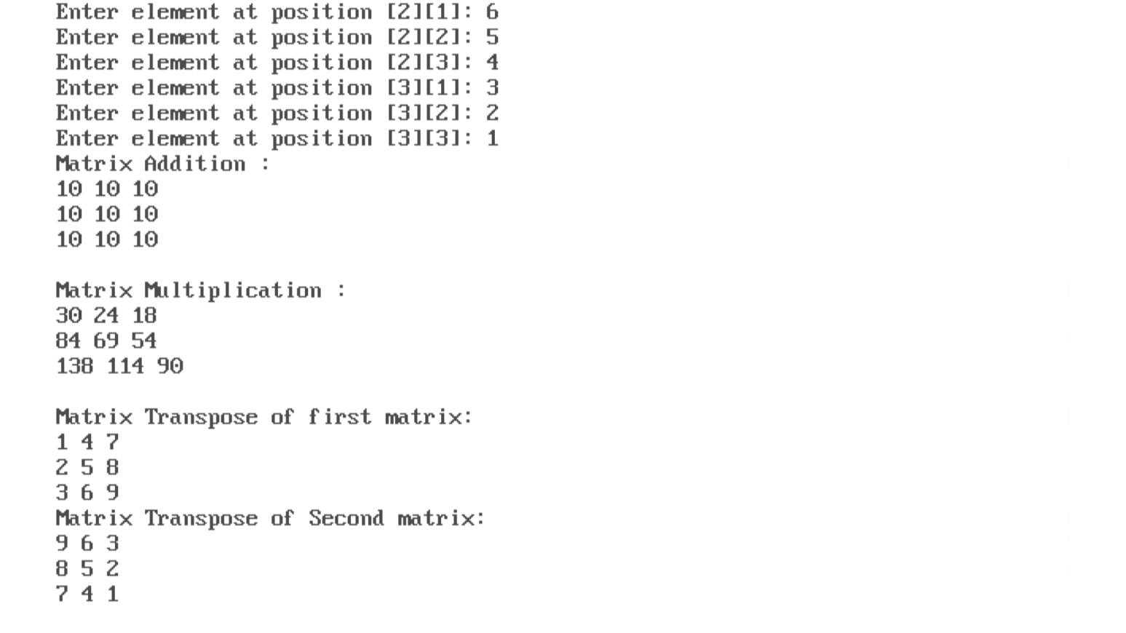

**7.c) WAP to create a 3-D matrix from given two 2-D matrices of size 3x4.**

#include <stdio.h>

#include <conio.h>

void main()

{

    int matrix1[3][4], i, j, k;

    int matrix2[3][4], result_3d_matrix[2][3][4];

    clrscr();

    printf("Enter values for the first matrix (3x4):\n");

    for (i = 0; i < 3; i++)

    {

        for (j = 0; j < 4; j++)

        {

            scanf("%d", &matrix1[i][j]);

        }

    }

    printf("Enter values for the second matrix (3x4):\n");

    for (i = 0; i < 3; i++)

    {

        for (j = 0; j < 4; j++)

        {

            scanf("%d", &matrix2[i][j]);

        }

    }

    for (k = 0; k < 2; k++)

    {

        for (i = 0; i < 3; i++)

        {

            for (j = 0; j < 4; j++)

            {

                result_3d_matrix[k][i][j] = (k == 0) ? matrix1[i][j] : matrix2[i][j];

            }

        }

    }

    printf("Resulting 3D Matrix:\n");

    for (k = 0; k < 2; k++)

    {

        for (i = 0; i < 3; i++)

        {

            for (j = 0; j < 4; j++)

            {

                printf("%d\t", result_3d_matrix[k][i][j]);

            }

            printf("\n");

        }

        printf("\n");

    }

    getch();

}

***OUTPUT***

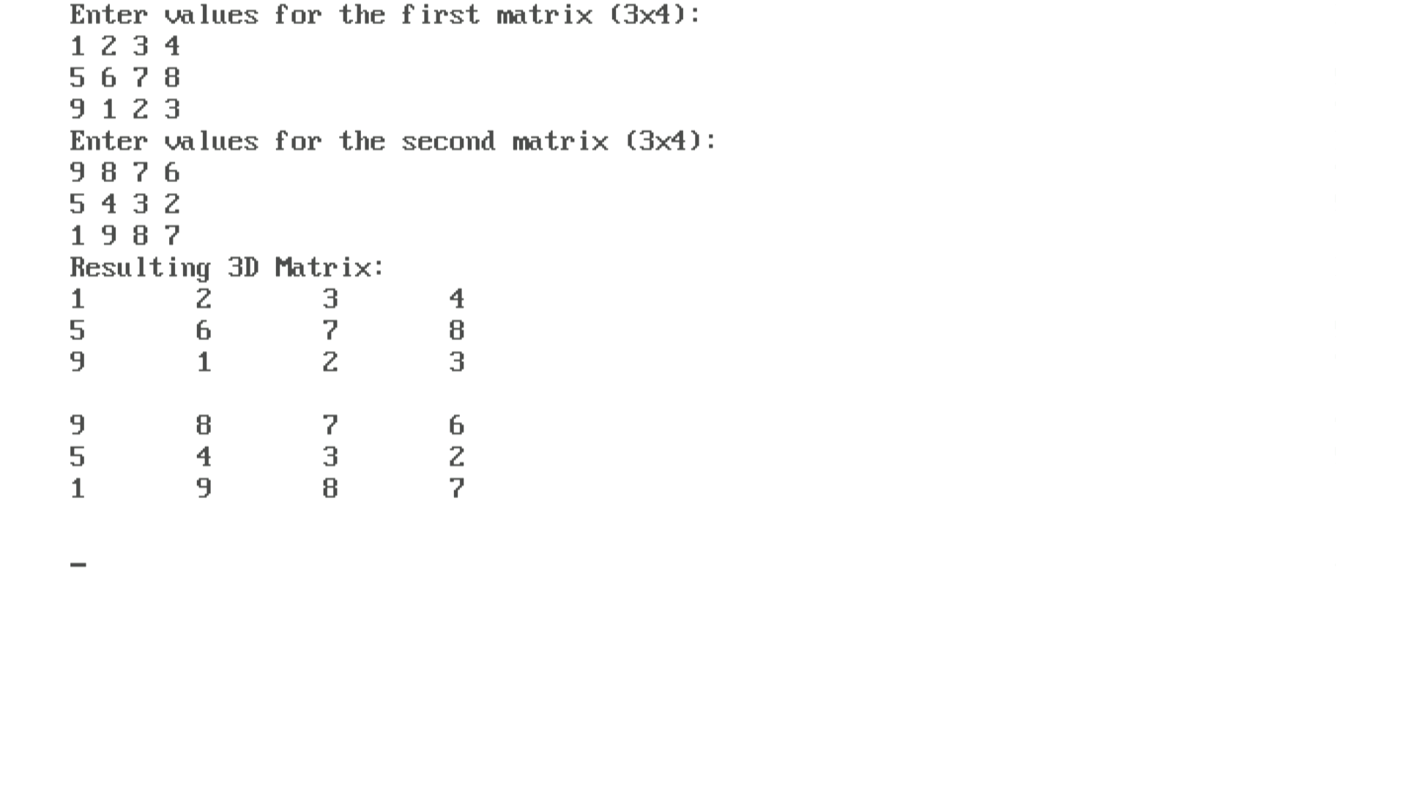

**7.d) WAP to concatenate 2 strings without using any pre-defined functions.**

#include <stdio.h>

#include <conio.h>

void concatenateStrings(char result[], char str1[], char str2[])

{

    int i, j;

    for (i = 0; str1[i] != '\0'; i++)

    {

        result[i] = str1[i];

    }

    for (j = 0; str2[j] != '\0'; j++)

    {

        result[i + j] = str2[j];

    }

    result[i + j] = '\0';

}

void main()

{

    char str1[50], str2[50], result[100];

    clrscr();

    printf("Enter the first string: ");

    gets(str1);

    printf("Enter the second string: ");

    gets(str2);

    concatenateStrings(result, str1, str2);

    printf("Concatenated string: %s\n", result);

    getch();

}

***OUTPUT***

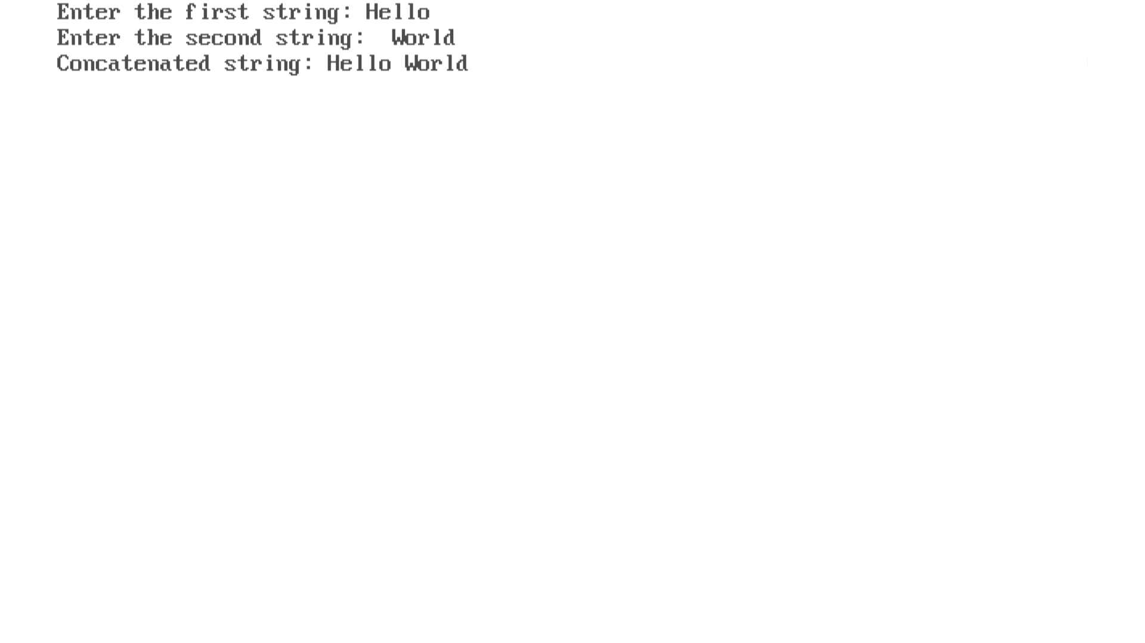

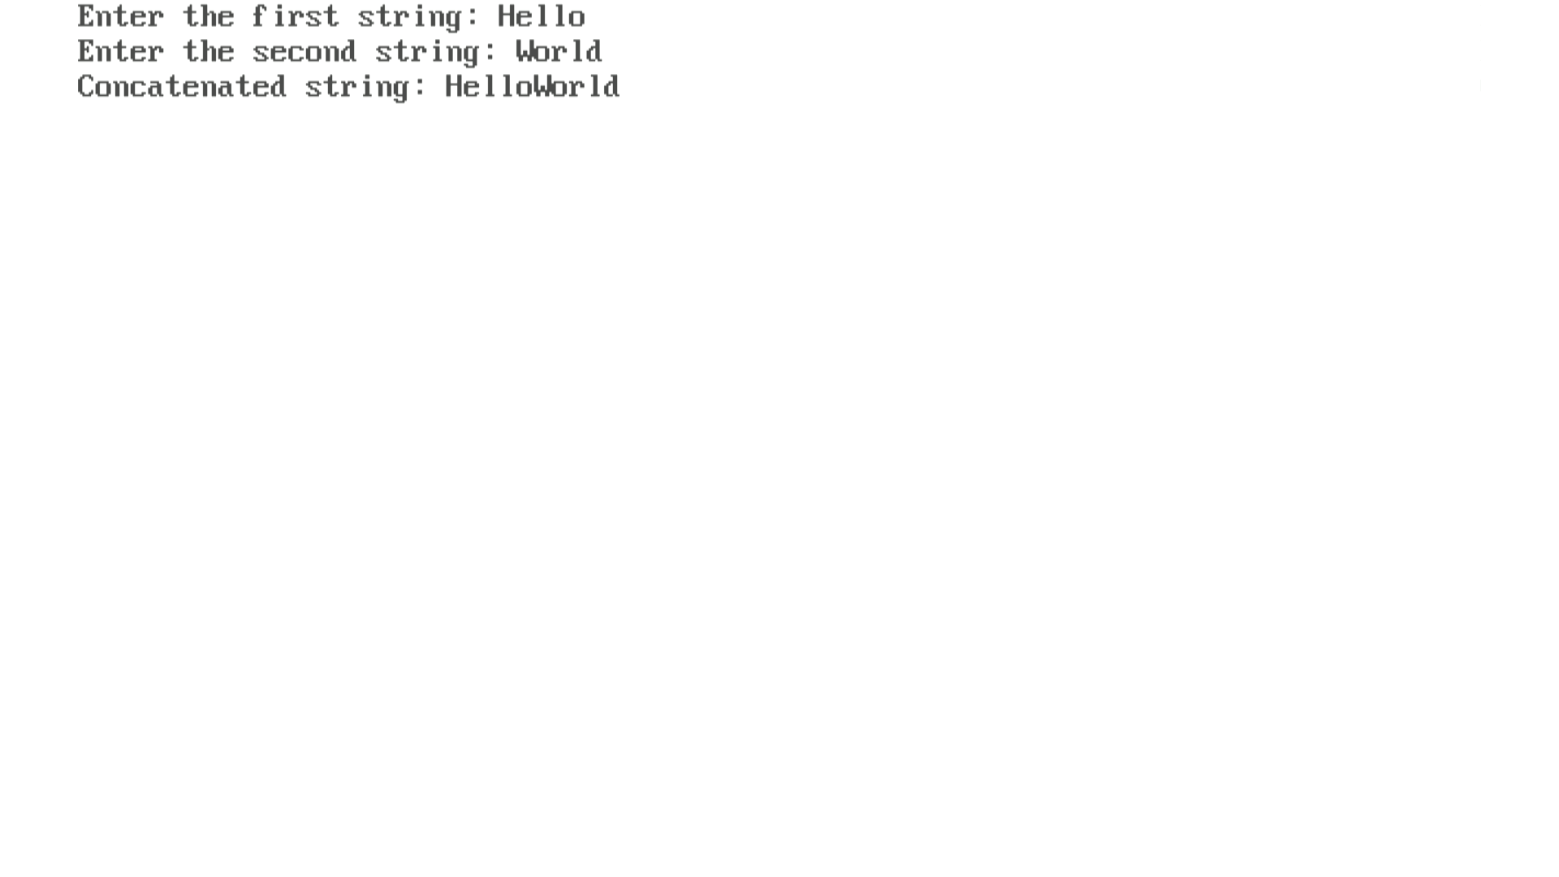

**7.e) WAP to check whether a string is a palindromic string or not.**

#include <stdio.h>

#include <conio.h>

#include <string.h>

int isPalindrome(char str[])

{

    int length = strlen(str);

    int i, j;

    for (i = 0, j = length - 1; i < j; i++, j--)

    {

        if (str[i] != str[j])

        {

            return 0;

        }

    }

    return 1;

}

void main()

{

    char str[100];

    clrscr();

    printf("Enter a string: ");

    gets(str);

    if (isPalindrome(str))

    {

        printf("%s is a palindrome.\n", str);

    }

    else

    {

        printf("%s is not a palindrome.\n", str);

    }

    getch();

}

***OUTPUT***

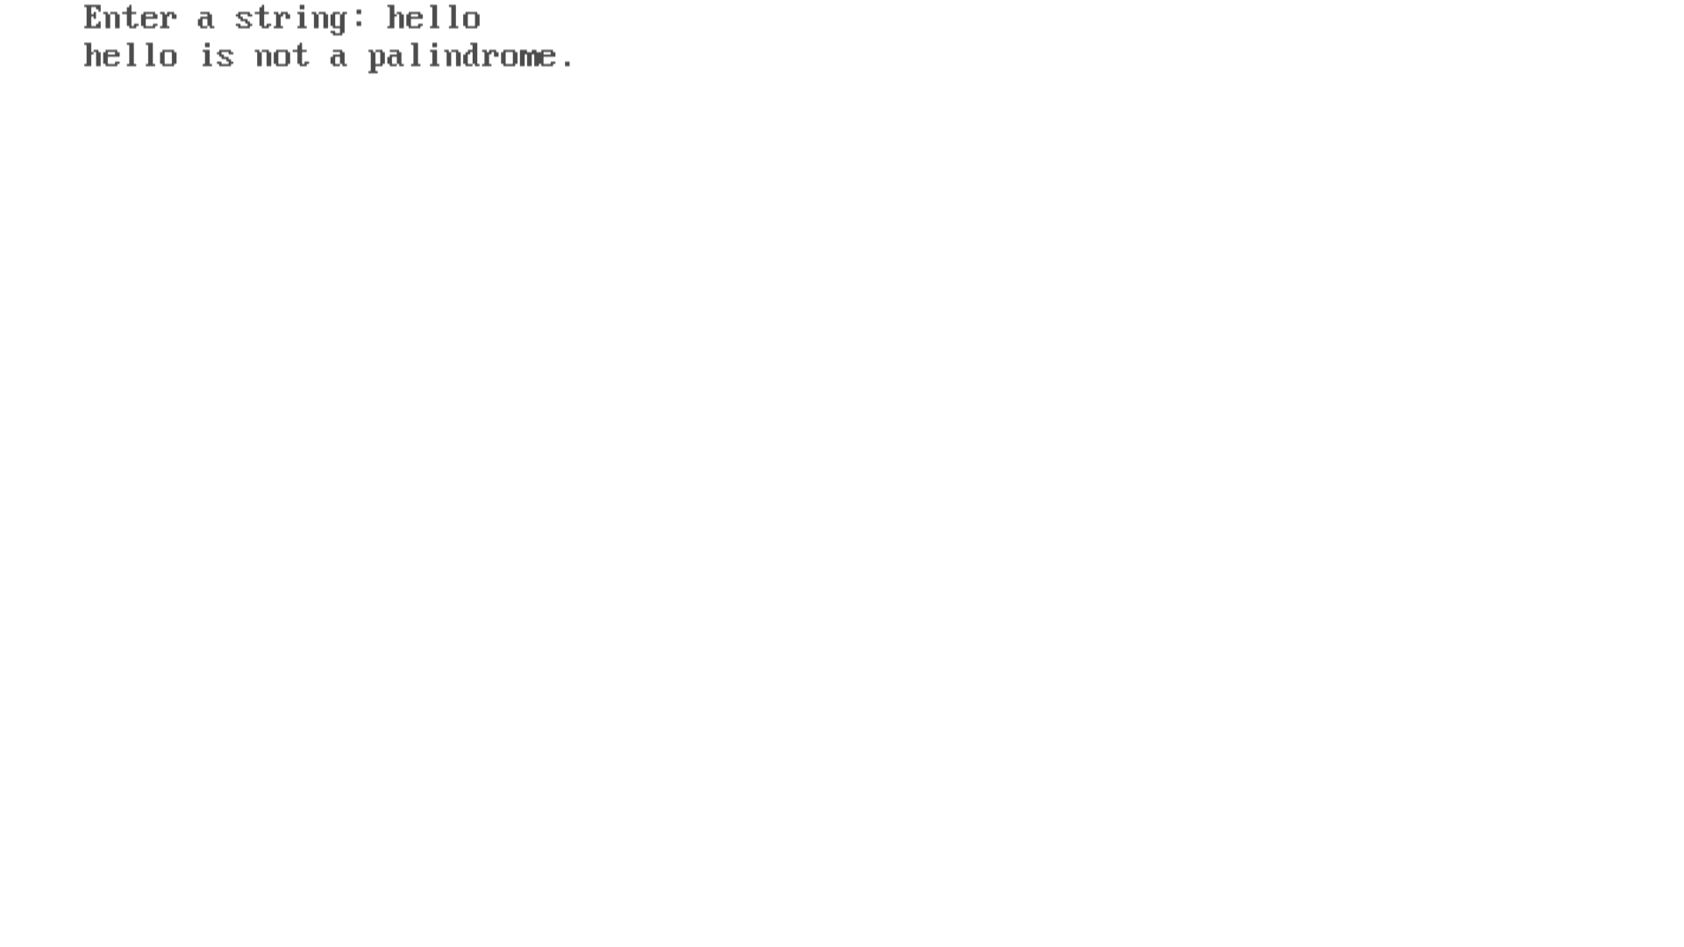

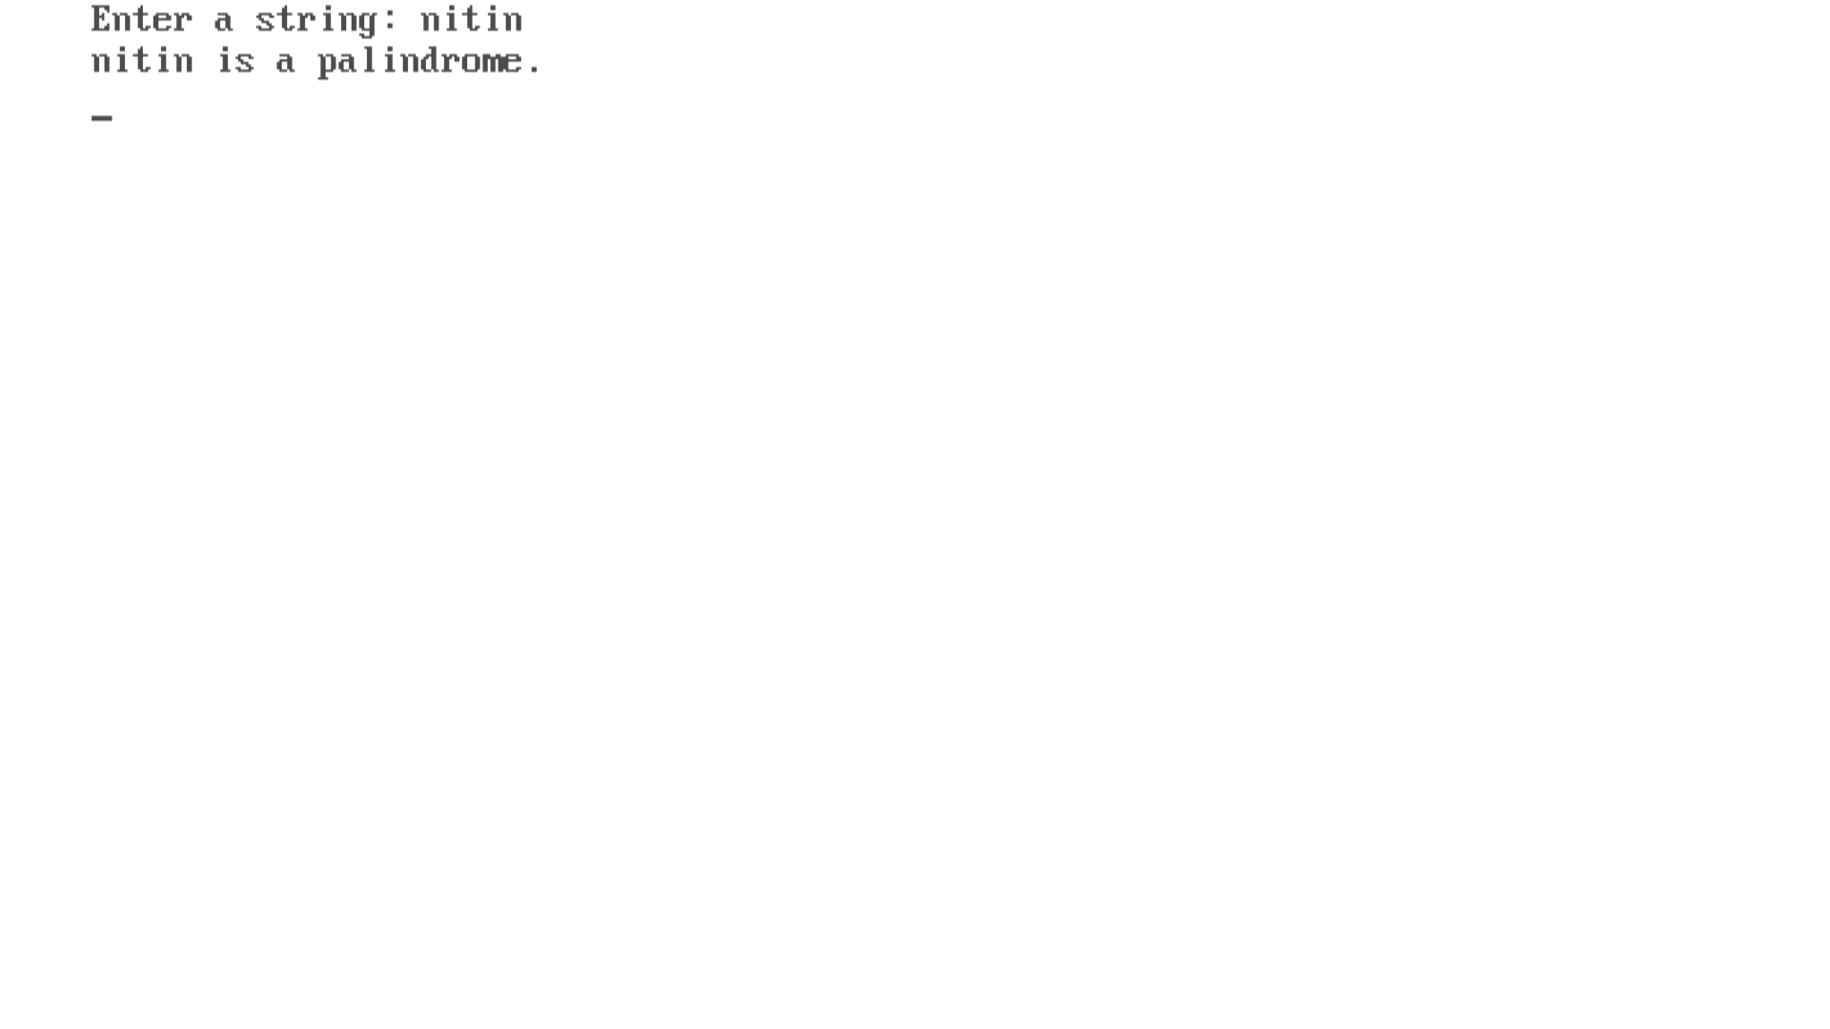

**8.a) Define a structure called Employee that will describe the following information: Employee name,Employee ID,Monthly Salary.**

**Using Employee, declare an array of 50 employees and WAP to read the information of all the employees and print the employee names with the highest and lowest salary. Also, calculate the average salary.**

#include <stdio.h>

#include <string.h>

struct Employee

{

    char name[50];

    int employeeID;

    int salary;

};

void main()

{

    struct Employee emp[5];

    int i, hindex = 0, lindex = 0;

    int totalSalary = 0, averageSalary;

    clrscr();

    for (i = 0; i < 5; ++i)

    {

        printf("Enter information for Employee %d:\n", i + 1);

        printf("Name: ");

        scanf("%s", emp[i].name);

        printf("Employee ID: ");

        scanf("%d", &emp[i].employeeID);

        printf("Monthly Salary: ");

        scanf("%d", &emp[i].salary);

    }

    for (i = 0; i < 5; ++i)

    {

        totalSalary += emp[i].salary;

    }

    averageSalary = totalSalary / 5;

    for (i = 1; i < 5; ++i)

    {

        if (emp[i].salary > emp[hindex].salary)

        {

            hindex = i;

        }

        if (emp[i].salary < emp[lindex].salary)

        {

            lindex = i;

        }

    }

    printf("\nEmployee with the highest salary:\n");

    printf("Name: %s\n", emp[hindex].name);

    printf("Employee ID: %d\n", emp[hindex].employeeID);

    printf("Monthly Salary: %d\n", emp[hindex].salary);

    printf("\nEmployee with the lowest salary:\n");

    printf("Name: %s\n", emp[lindex].name);

    printf("Employee ID: %d\n", emp[lindex].employeeID);

    printf("Monthly Salary: %d\n", emp[lindex].salary);

    printf("\nAverage Salary: %d\n", averageSalary);

    getch();

}

***OUTPUT***

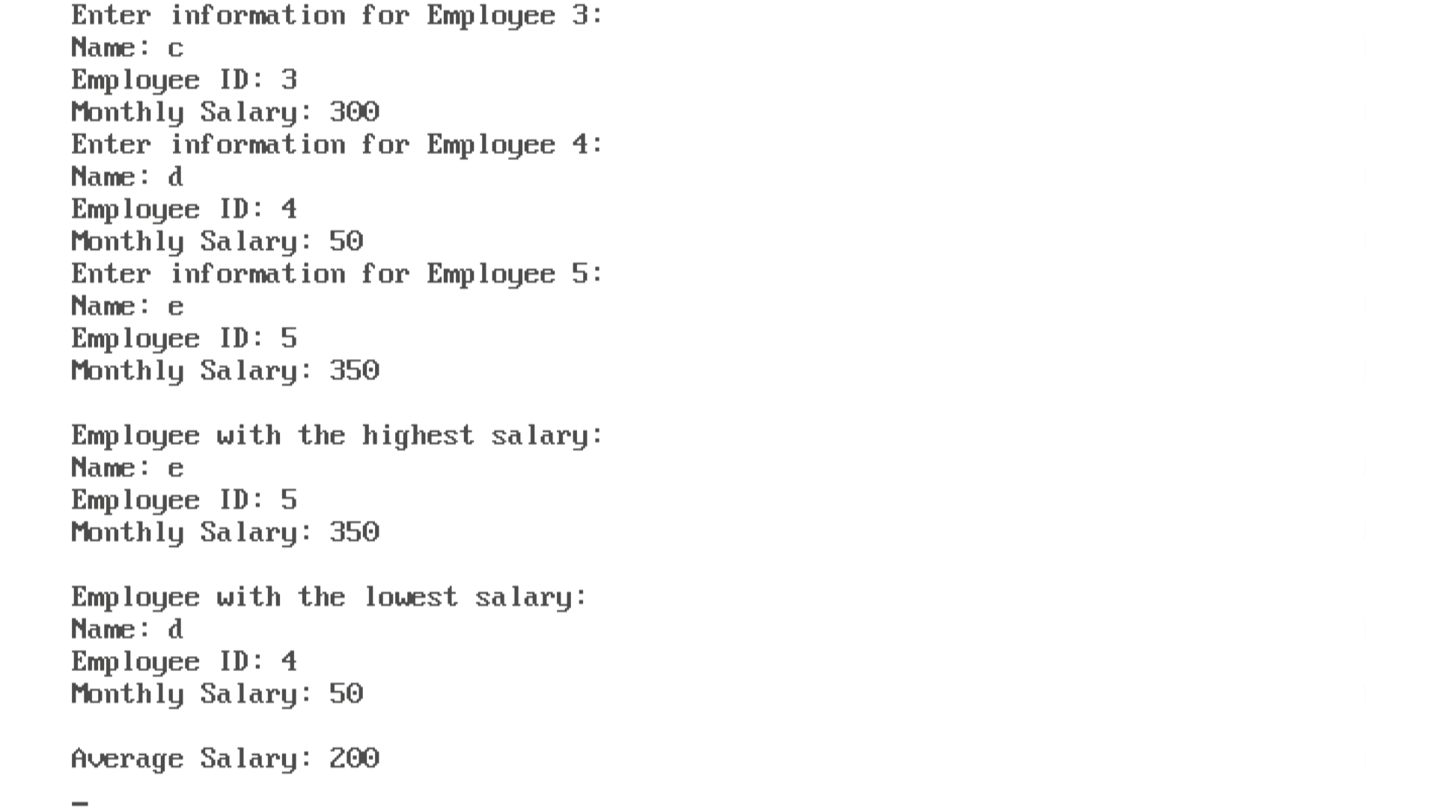

**8.b) WAP using union and structure to find the average salary of 50 employees with the following information:**

**Employee Name / Employee ID**

**Employee monthly salary**

#include <stdio.h>

#include <string.h>

union EmployeeInfo

{

    char name[50];

    int employeeID;

    int salary;

};

struct Employee

{

    union EmployeeInfo info;

};

void main()

{

    struct Employee emp[5];

    int i, totalSalary = 0, averageSalary;

    clrscr();

    for (i = 0; i < 5; ++i)

    {

        printf("Enter information for Employee %d:\n", i + 1);

        printf("Name: ");

        scanf("%s", emp[i].info.name);

        printf("Employee ID: ");

        scanf("%d", &emp[i].info.employeeID);

        printf("Monthly Salary: ");

        scanf("%d", &emp[i].info.salary);

    }

    for (i = 0; i < 5; ++i)

    {

        totalSalary += emp[i].info.salary;

    }

    averageSalary = totalSalary / 5;

    printf("\nAverage Salary: %d\n", averageSalary);

    getch();

}

***OUTPUT***

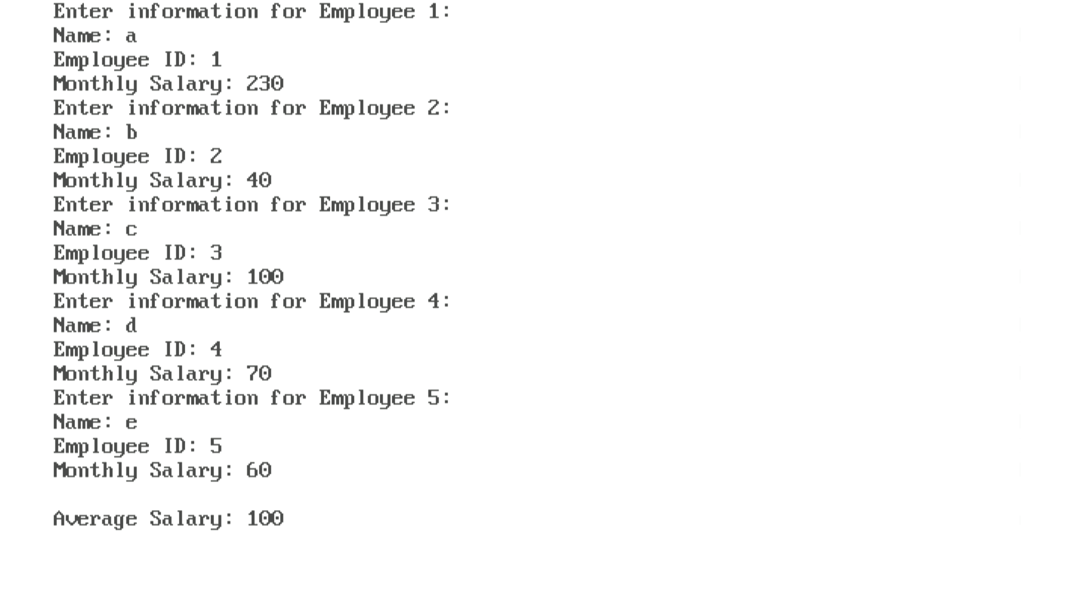

**9.a)Using call by reference, write a program to swap two numbers using 2 variables.**

#include <stdio.h>

#include <conio.h>

void swap(int *a, int *b)

{

    *a = *a + *b;

    *b = *a - *b;

    *a = *a - *b;

}

void main()

{

    int num1, num2;

    clrscr();

    printf("Enter the first number: ");

    scanf("%d", &num1);

    printf("Enter the second number: ");

    scanf("%d", &num2);

    printf("Before swapping: num1 = %d, num2 = %d\n", num1, num2);

    swap(&num1, &num2);

    printf("After swapping: num1 = %d, num2 = %d\n", num1, num2);

    getch();

}

***OUTPUT***

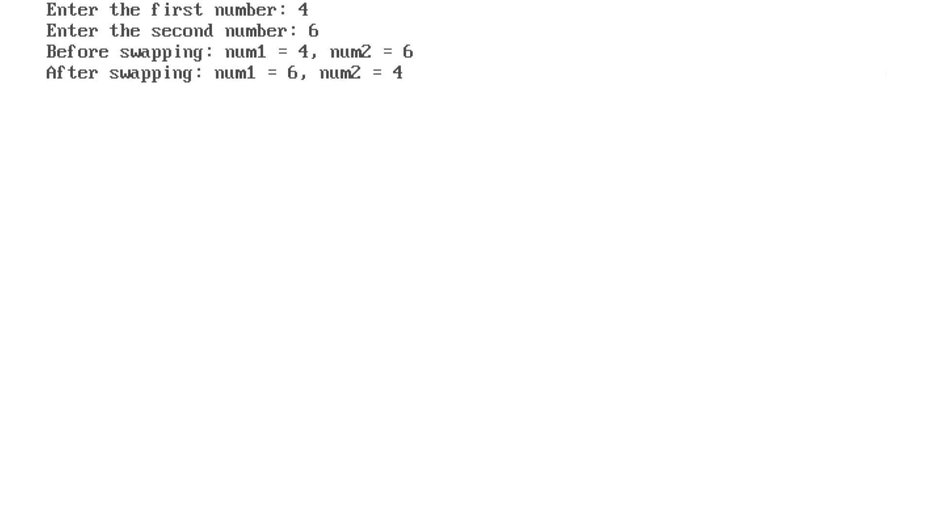

**9.b)Using call by reference, write a program to swap two numbers using 3 variables.**

#include <stdio.h>

#include <conio.h>

void swap(int *a, int *b)

{

    int temp = *a;

    *a = *b;

    *b = temp;

}

void main()

{

    int num1, num2;

    clrscr();

    printf("Enter the first number: ");

    scanf("%d", &num1);

    printf("Enter the second number: ");

    scanf("%d", &num2);

    printf("Before swapping: num1 = %d, num2 = %d\n", num1, num2);

    swap(&num1, &num2);

    printf("After swapping: num1 = %d, num2 = %d\n", num1, num2);

    getch();

}

***OUTPUT***

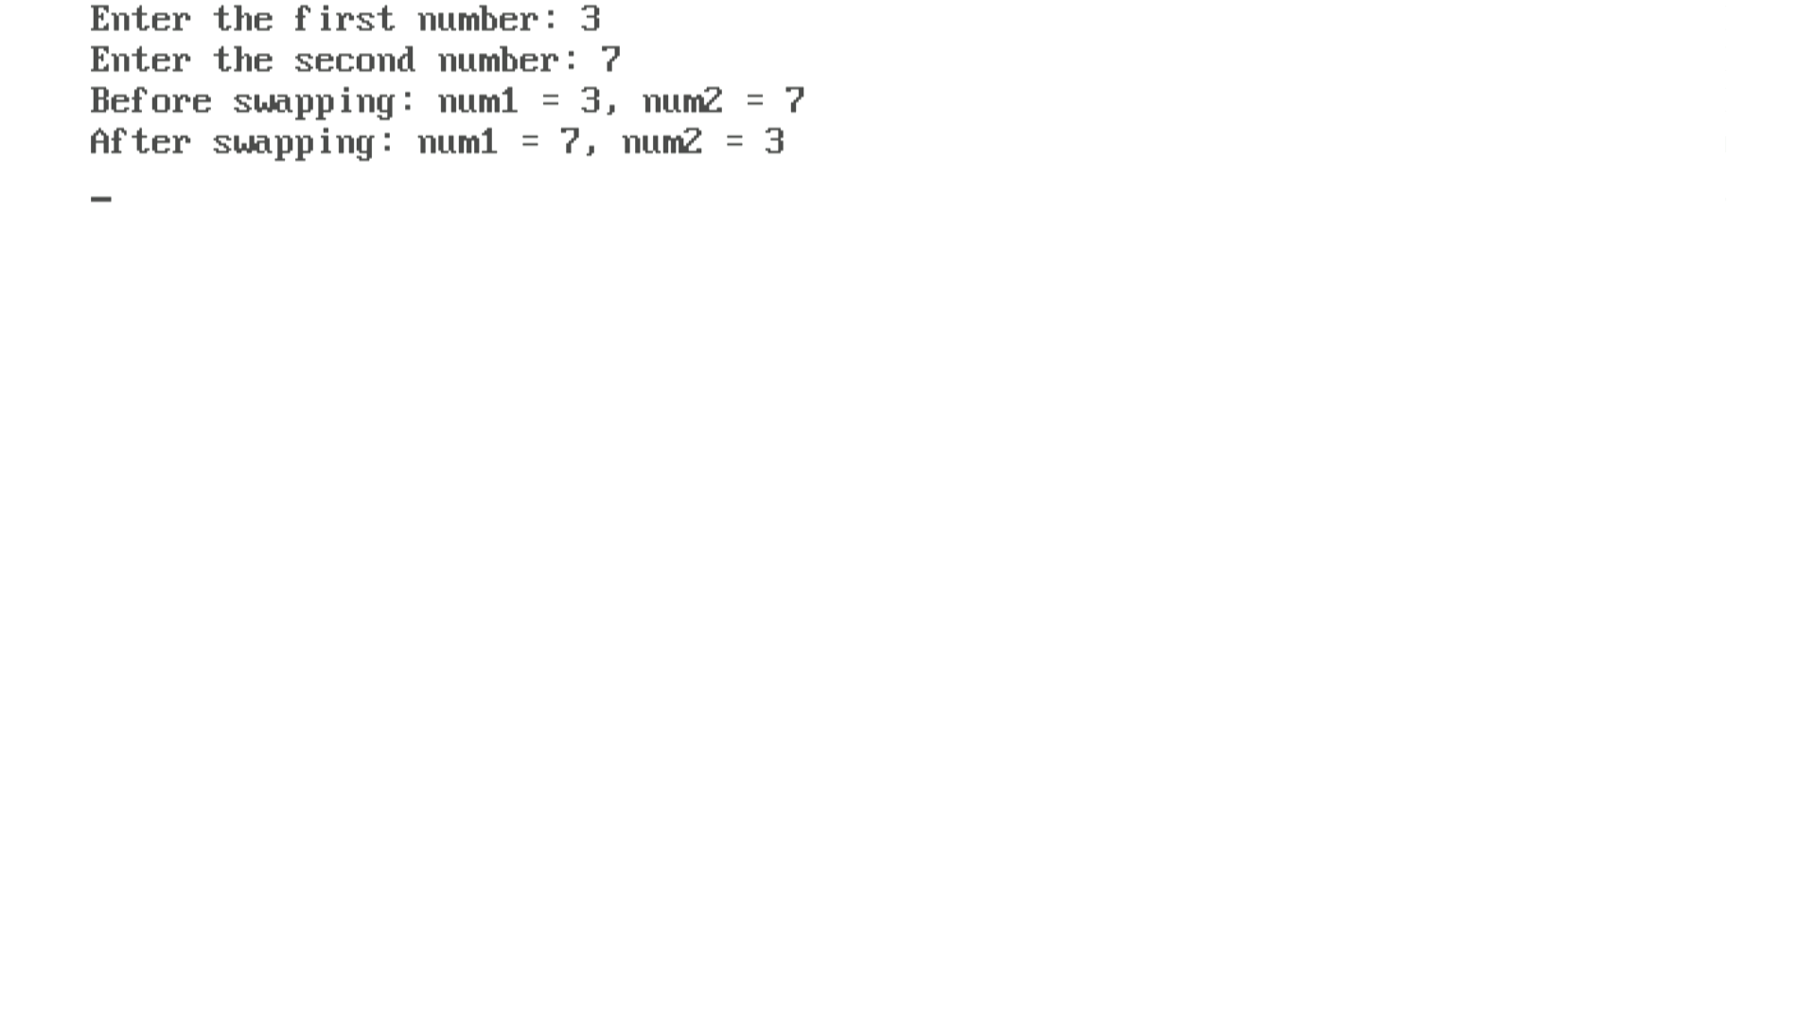

**10.a) WAP in C to copy the content of one to another file.**

#include <stdio.h>

#include <conio.h>

void main()

{

FILE *sourceFile, *destinationFile;

char file1[50], file2[50];

char ch;

clrscr();

printf("Enter the source file name: ");

scanf("%s", file1);

sourceFile = fopen(file1, "r");

printf("Enter the destination file name: ");

scanf("%s", file2);

destinationFile = fopen(file2, "w");

if (sourceFile == NULL || destinationFile == NULL)

{

printf("Error opening source file");

}

else

{

while ((ch = fgetc(sourceFile)) != EOF)

{

fputc(ch, destinationFile);

}

printf("File copy successfully from source to destination file\n");

}

fclose(sourceFile);

fclose(destinationFile);

getch();

}

***OUTPUT***

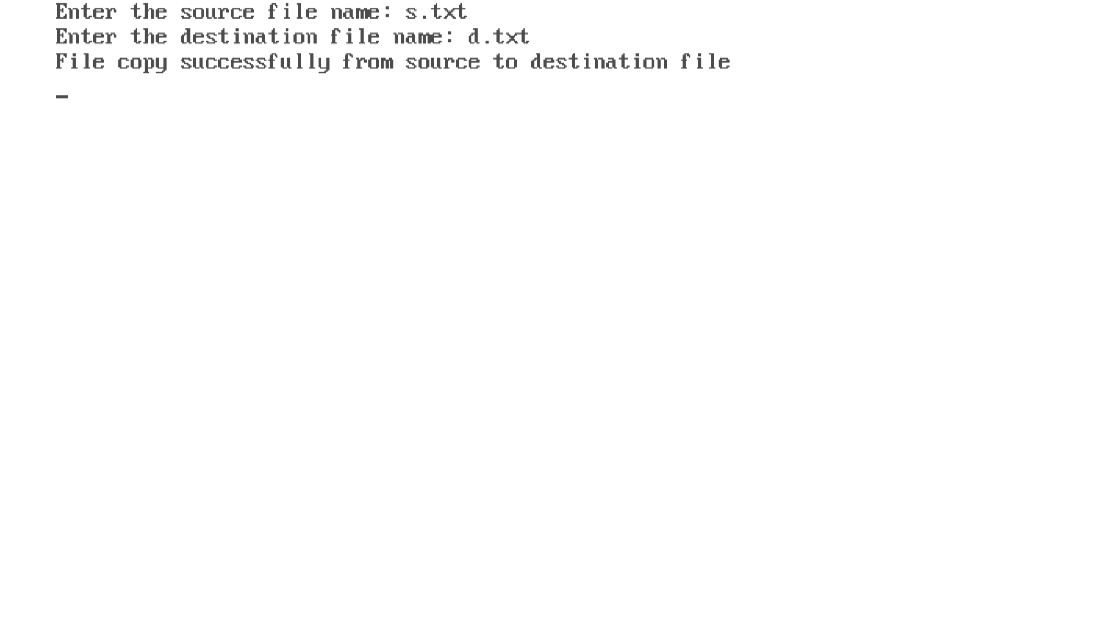

***Source and destination text file before copy***

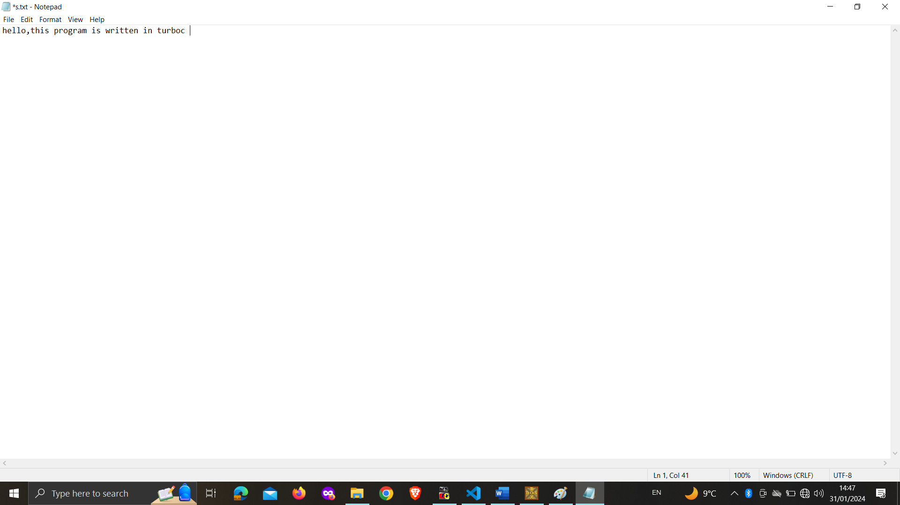

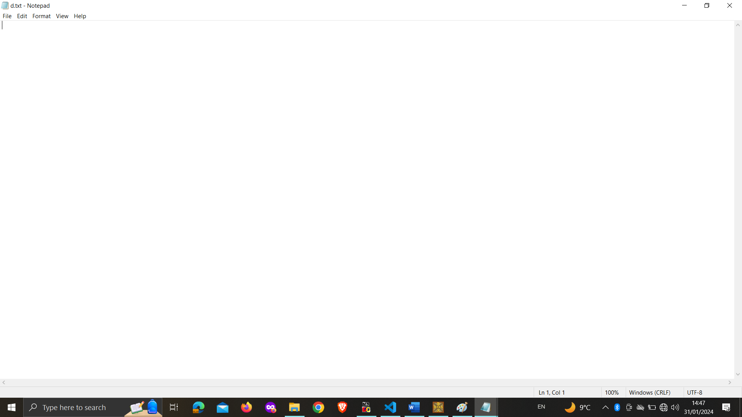

***Source and destination text file after copy***



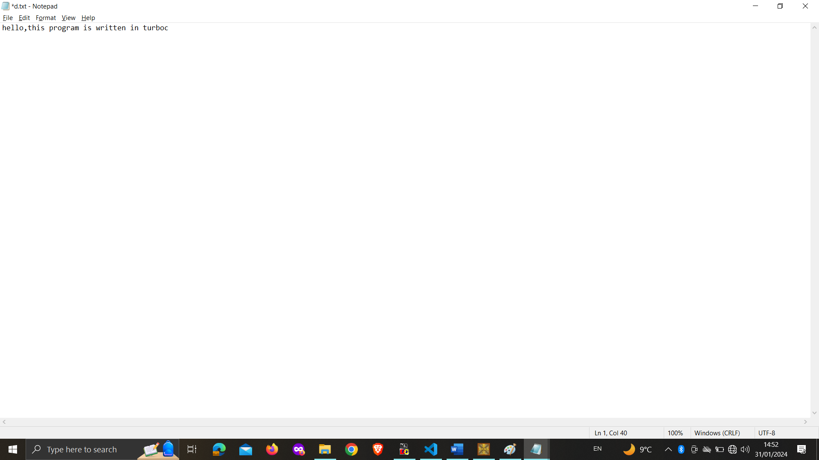

**10.b) WAP to make a circle, square, and rectangle using built-in functions in computer graphics.**

#include <stdio.h>

#include <conio.h>

#include <graphics.h>

void main()

{

    int gd = DETECT, gm;

    clrscr();

    initgraph(&gd, &gm, "c:\\TURBOC3\\BGI");

    circle(60, 60, 50);

    outtextxy(40, 60, "Circle");

    rectangle(120, 20, 210, 110);

    outtextxy(140, 60, "Square");

    rectangle(230, 20, 380, 110);

    outtextxy(260, 60, "Rectangle");

    delay(3000);

    closegraph();

    getch();

}

***OUTPUT***

